Name _______________________________ Date _________________ Period _________
Chapter 10 Insurance Chapter Vocabulary Assignment
Word | Definition | Use it in a Sentence | Definition in your own words | Picture
antennae | either of a pair of long, thin sensory appendages on the heads of insects, crustaceans, and some other arthropods. | The grasshopper wiggled his antennae and scared me. | The thin rods on an insects head | 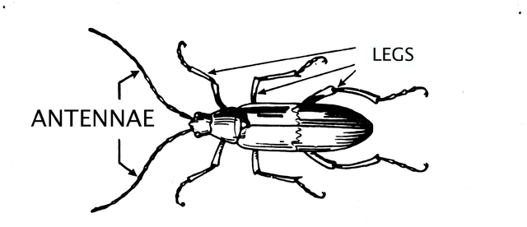  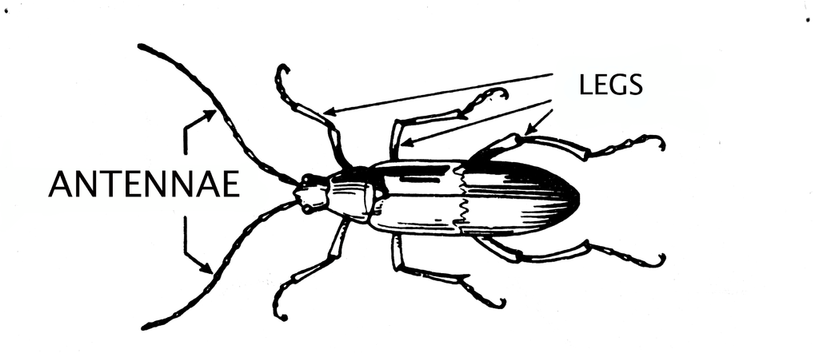
Claim
Coverage
Deductible
Insurability
Insurance
Insurance policy
Insured
Insurer
Liability
Premiums
Product options
Risk
Uninsured
Underinsured
Policy holder

